Project Development Phase
Model Performance Test

Date | 10 February 2026
Team ID | LTVIP2026TMIDS90862
Project Name | Prosperity Prognosticator: Machine Learning for Startup Success Prediction
Maximum Marks

Model Performance Testing:
Project team shall fill the following information in model performance testing template.
S.No. | Parameter | Values | Screenshot
 | Model Summary | Random Forest Classifier  n_estimators = 100  Random State = 42 | 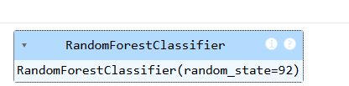
 | Accuracy | Training Accuracy - 1.00 (100%)  Validation Accuracy – 0.76 (76%) | 